**Figure A1. Participant Flow Diagram for Analytic Samples**

The diagram illustrates the derivation of the analytic samples from the original longitudinal cohort.

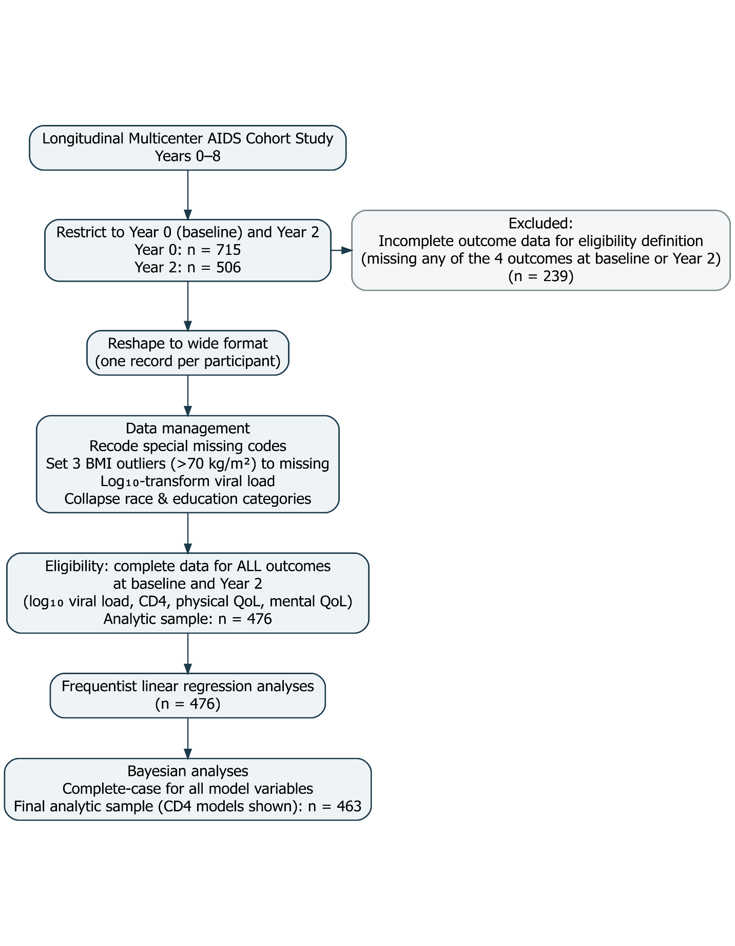

**Figure A2. Distributions of Baseline and Year 2 Outcomes**

Histograms display the distributions of viral load, CD4 cell count, and physical and mental quality-of-life scores at baseline (Year 0) and Year 2. Viral load values are presented on the original scale as recorded in the dataset. Scales differ across panels to reflect the natural range of each outcome. The histograms show marked right-skewness for viral load and approximately symmetric distributions for CD4 count and quality-of-life measures.

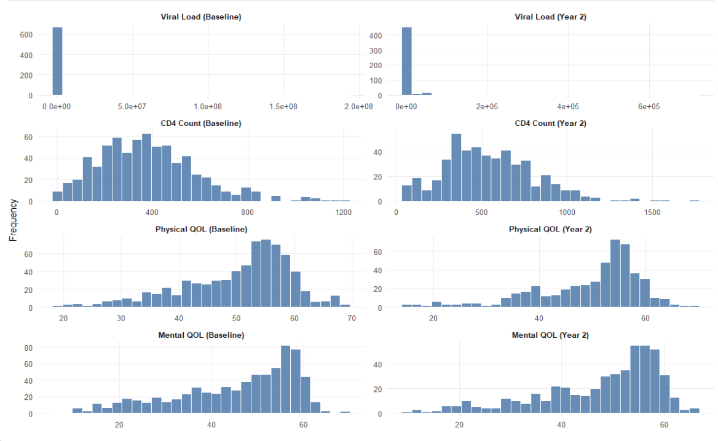

**Figure A3. Distribution of log₁₀ Viral Load at Baseline and Year 2**

Histograms display the distribution of log₁₀-transformed viral load at baseline (Year 0) and Year 2. The log transformation reduces the strong right-skewness observed when viral load is measured on the original scale. Following transformation, the distributions appear approximately symmetric, supporting the use of linear regression models in subsequent analyses.

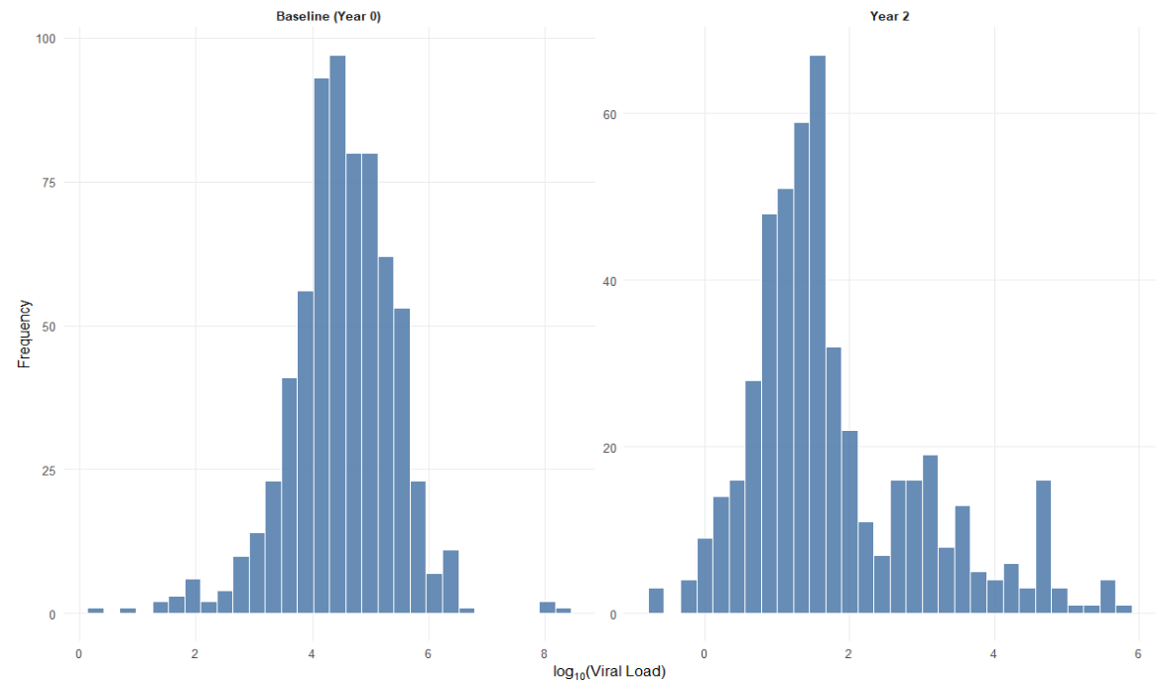

**Figure A4. Year 2 Adherence by Baseline Hard Drug Use Status**

The bar chart shows the number of participants in each Year 2 adherence category, stratified by baseline hard drug use status. Counts are displayed above each bar. Within each adherence category, participants reporting baseline hard drug use are presented first.

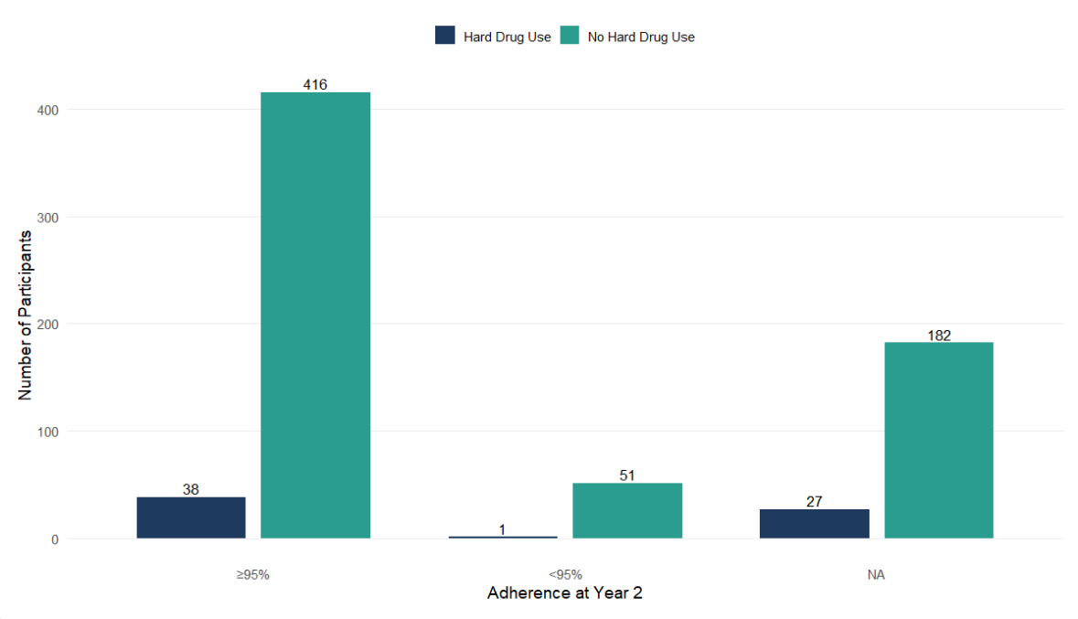

**Figures A5-A12. Diagnostic Tests**

Results of diagnostic tests for regression model assumptions are presented below. These include assessments of linearity, normality of residuals, homoscedasticity, and influential observations. Overall, diagnostic plots indicated no substantial violations of model assumptions.

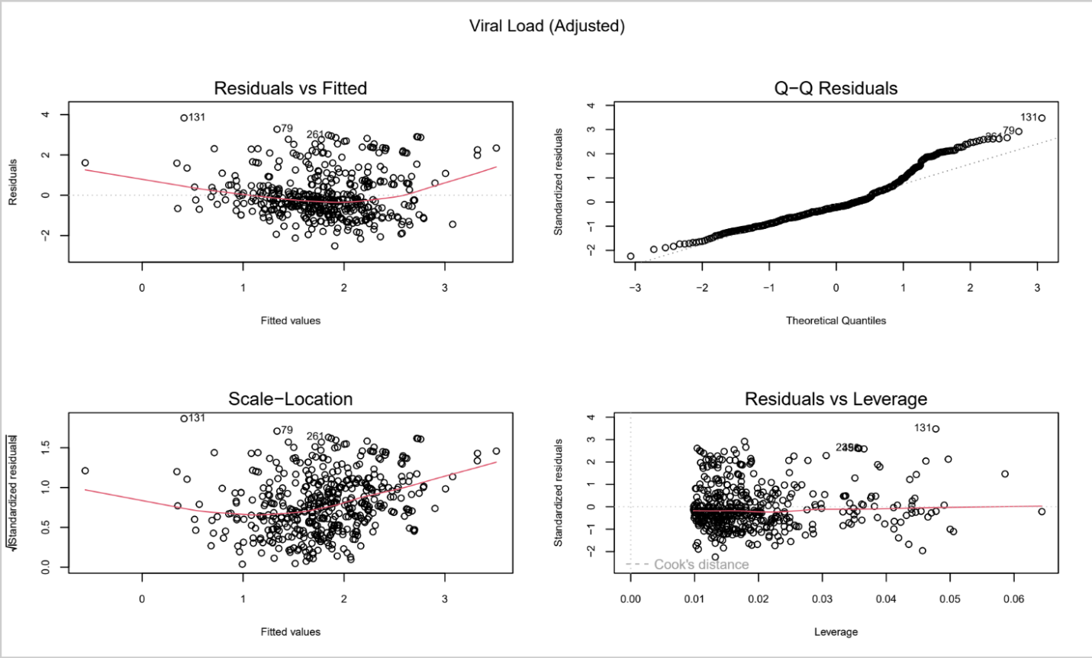

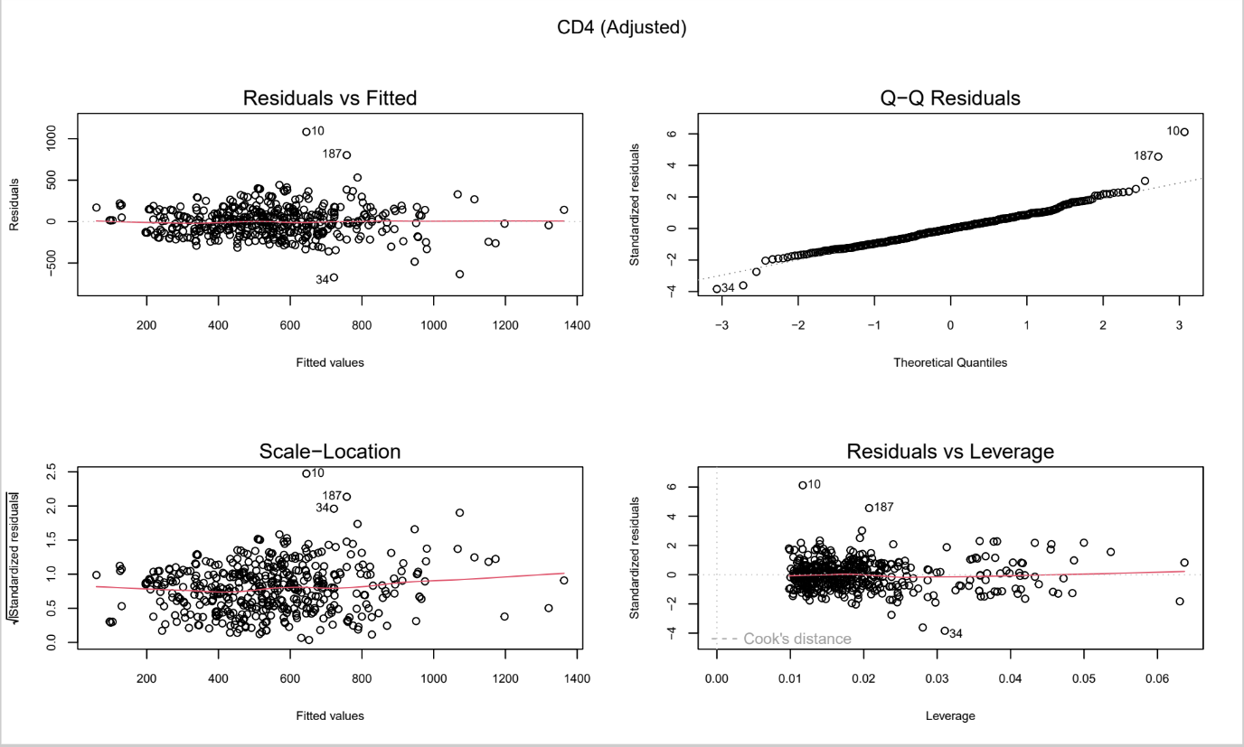

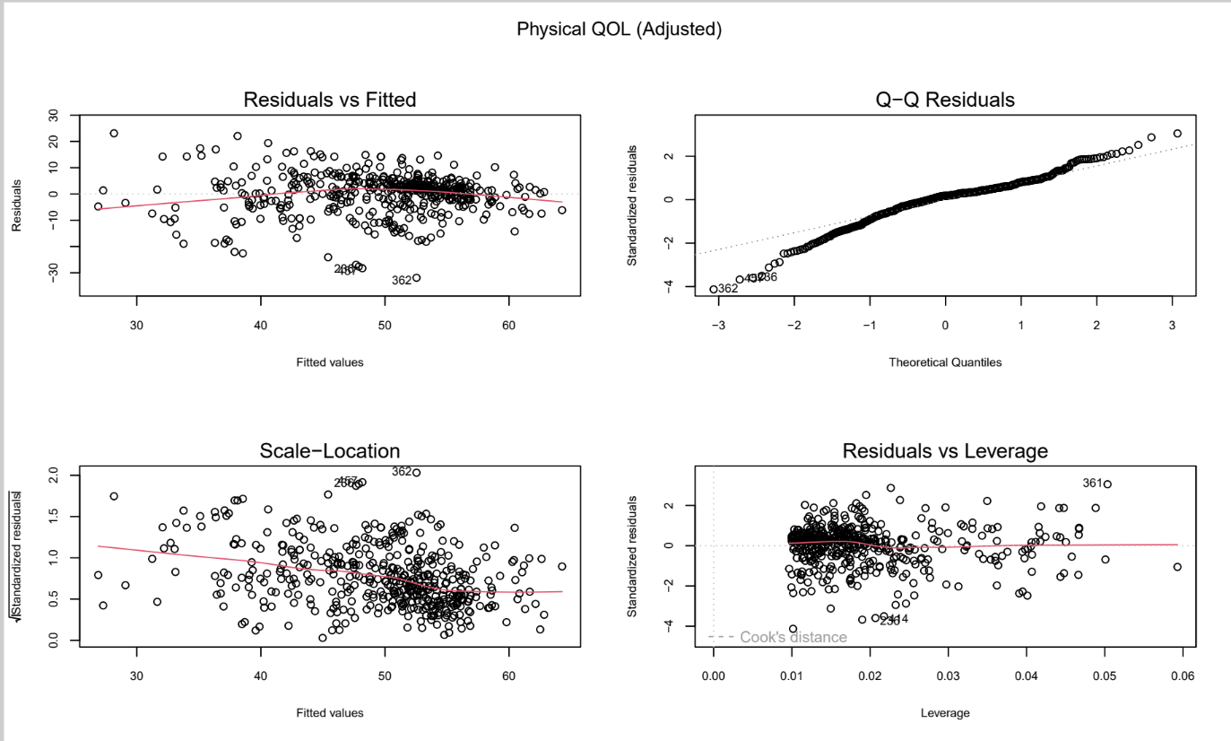

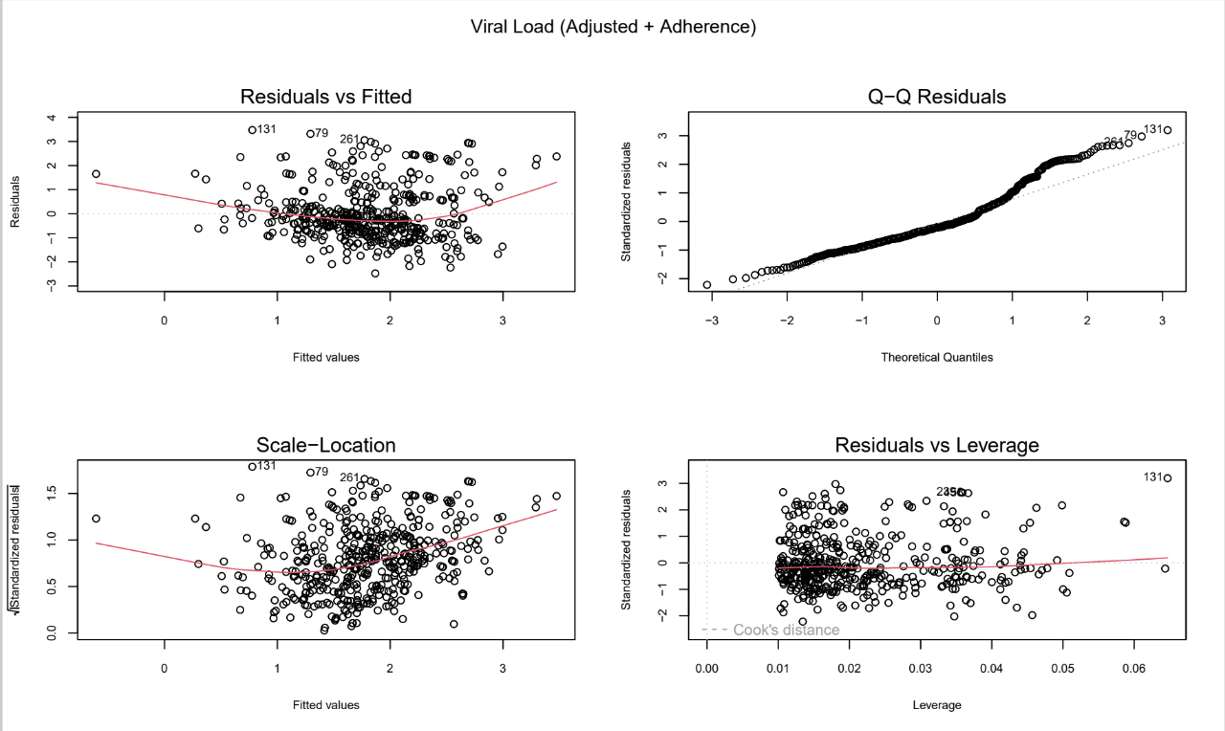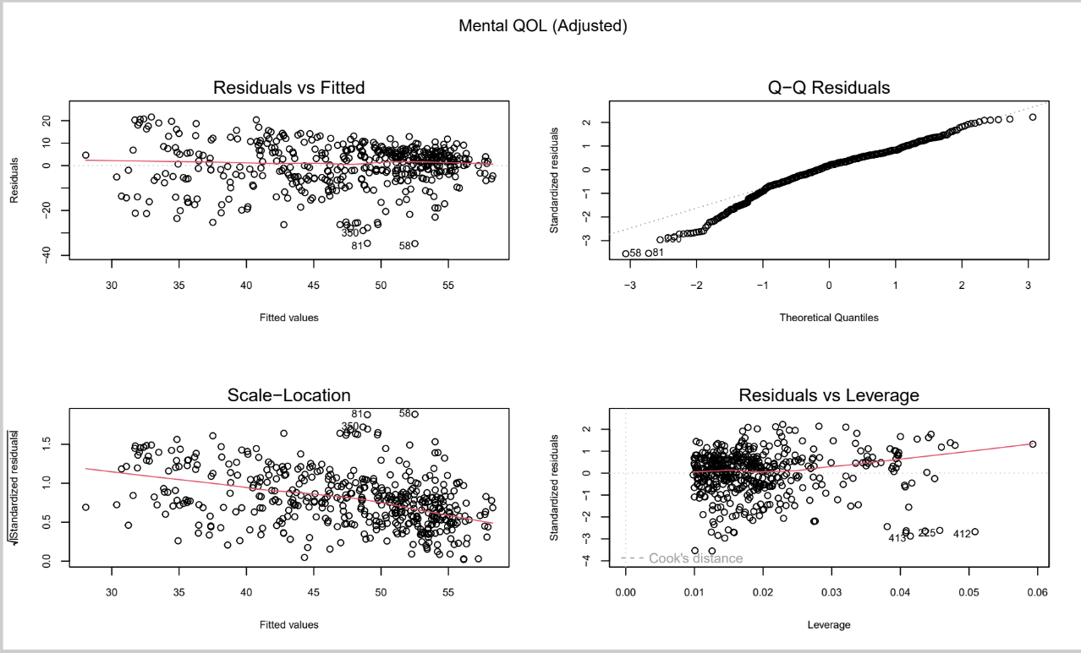

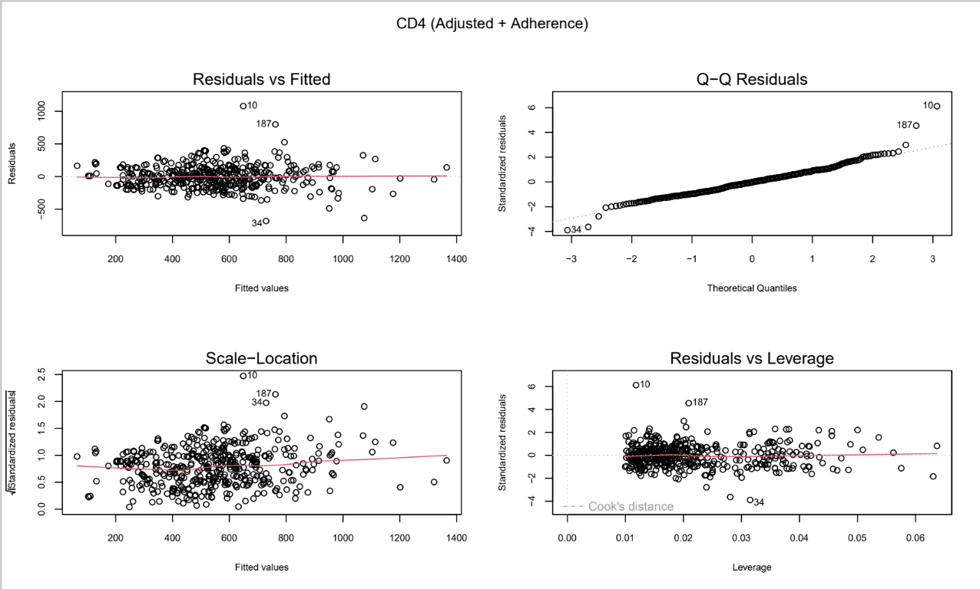

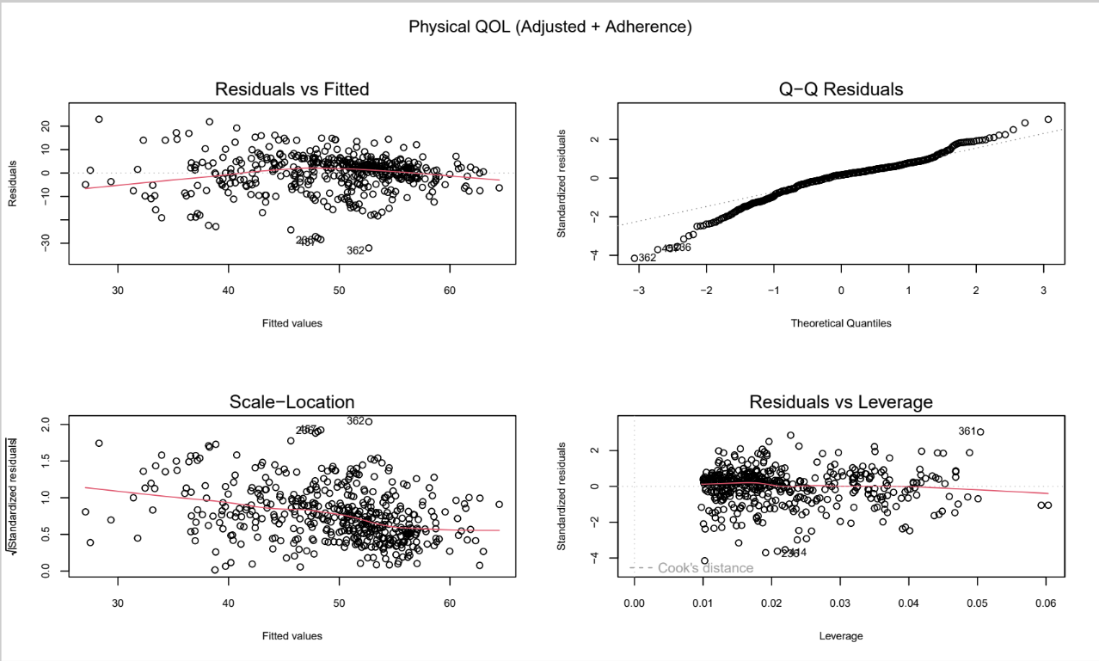

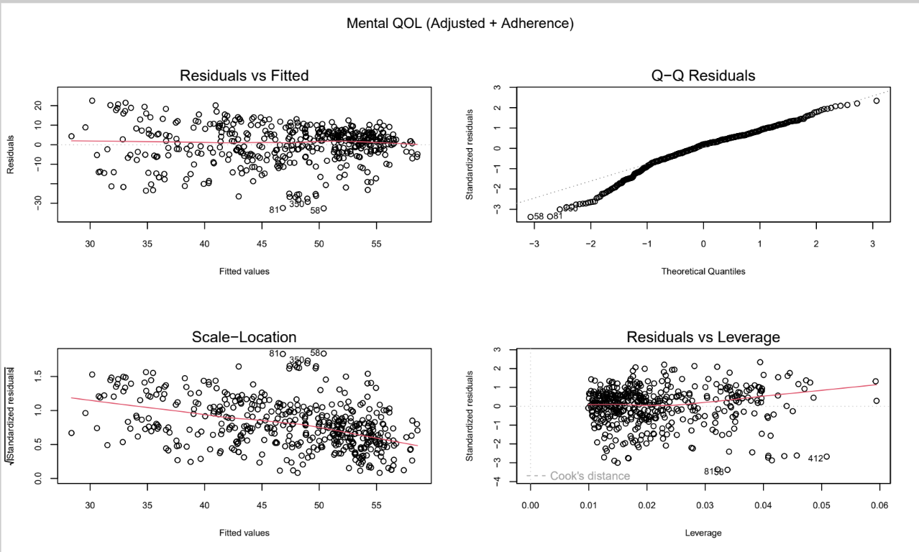

**Table A1. Model Fit Statistics for Adjusted and Adjusted + Adherence Frequentist Models (N = 463)**

|  |  |  |  |
| --- | --- | --- | --- |
| **Model** | **R²** | **Adjusted R²** | **RMSE** |
| Viral Load (Adjusted) | 0.1706 | 0.1560 | 1.1195 |
| CD4 (Adjusted) | 0.5639 | 0.5562 | 176.3097 |
| Physical QOL (Adjusted) | 0.4298 | 0.4197 | 7.6947 |
| Mental QOL (Adjusted) | 0.3336 | 0.3219 | 9.7476 |
| Viral Load (Adjusted + Adherence) | 0.1817 | 0.1655 | 1.1120 |
| CD4 (Adjusted + Adherence) | 0.5676 | 0.5591 | 175.5540 |
| Physical QOL (Adjusted + Adherence) | 0.4338 | 0.4226 | 7.6672 |
| Mental QOL (Adjusted + Adherence) | 0.3369 | 0.3237 | 9.7241 |

**Model Performance (A13- A36)**

**Viral Load adjusted**

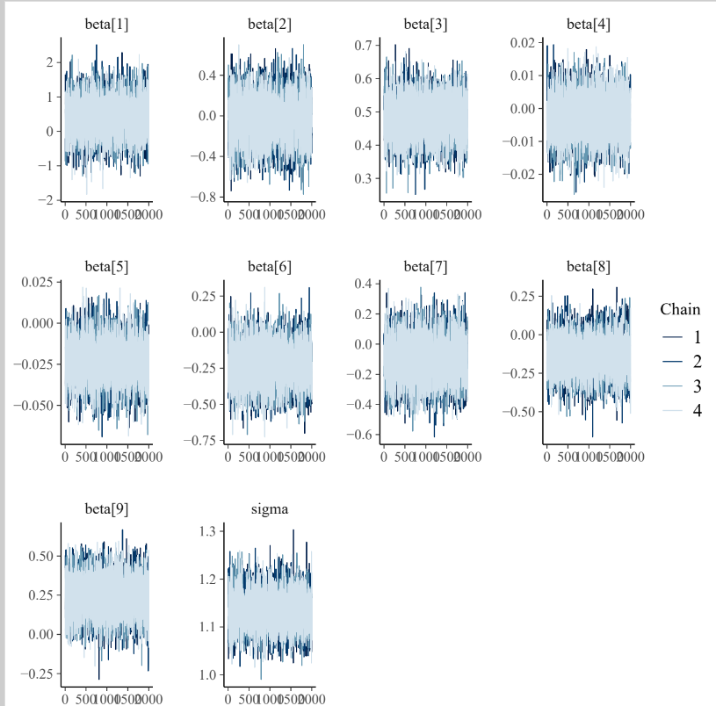

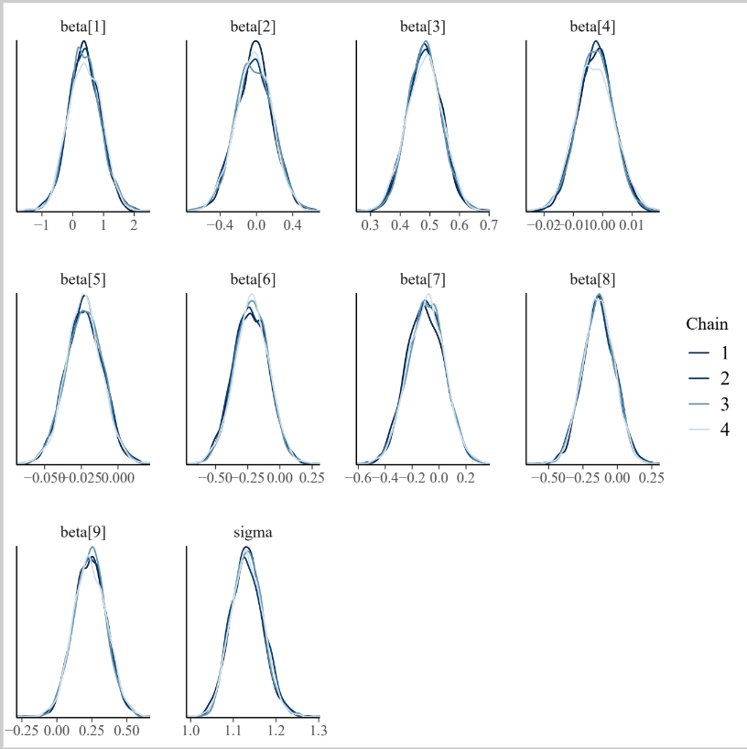

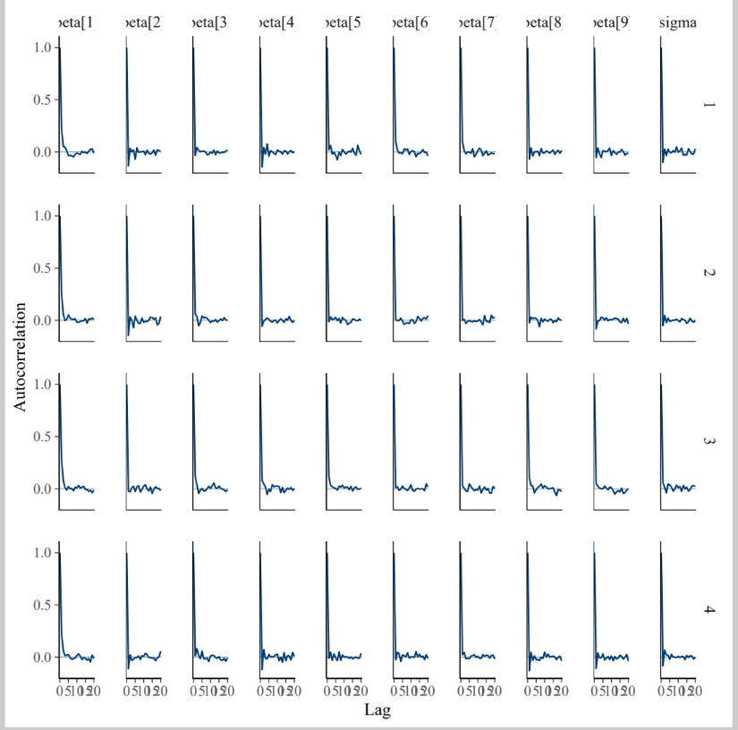

**Viral Load adjusted+ADH**

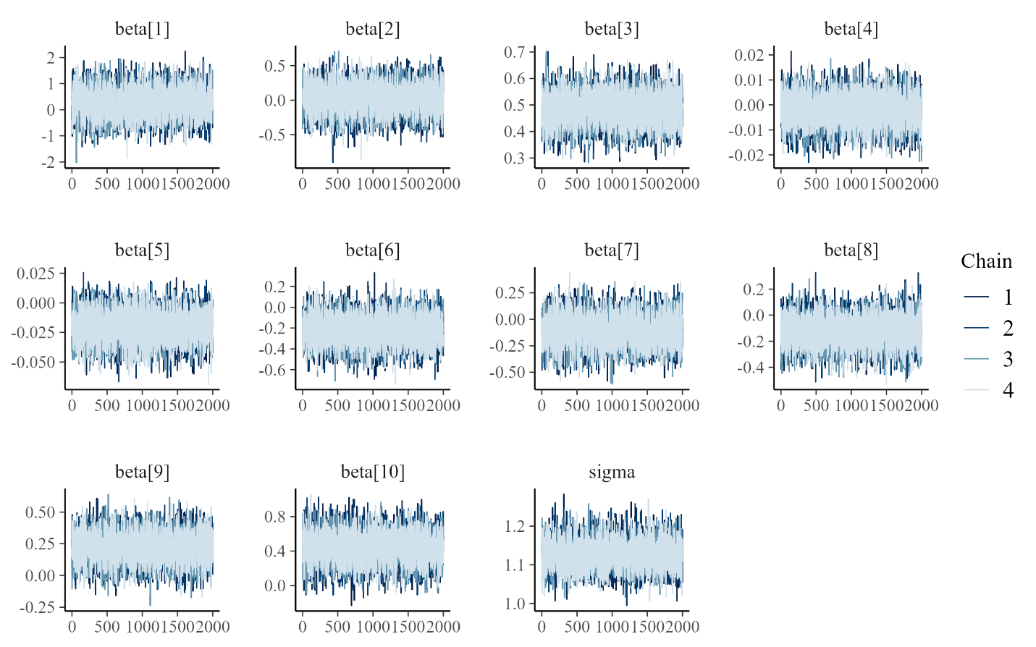

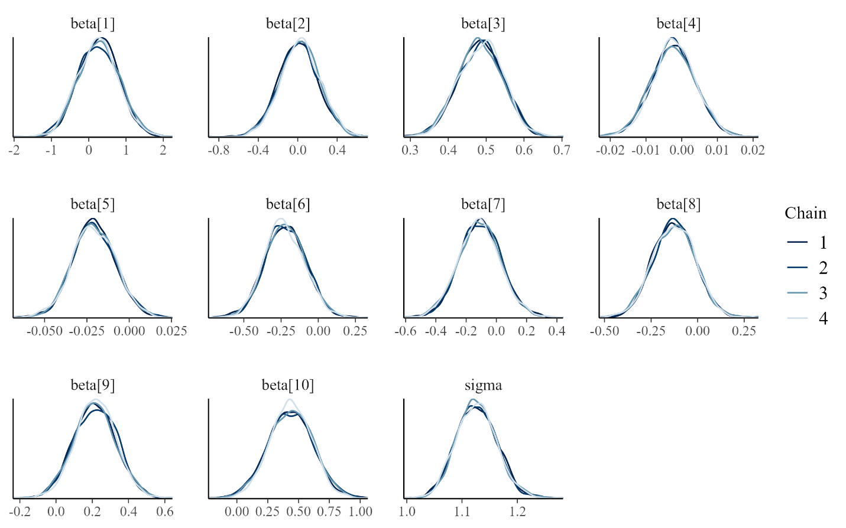

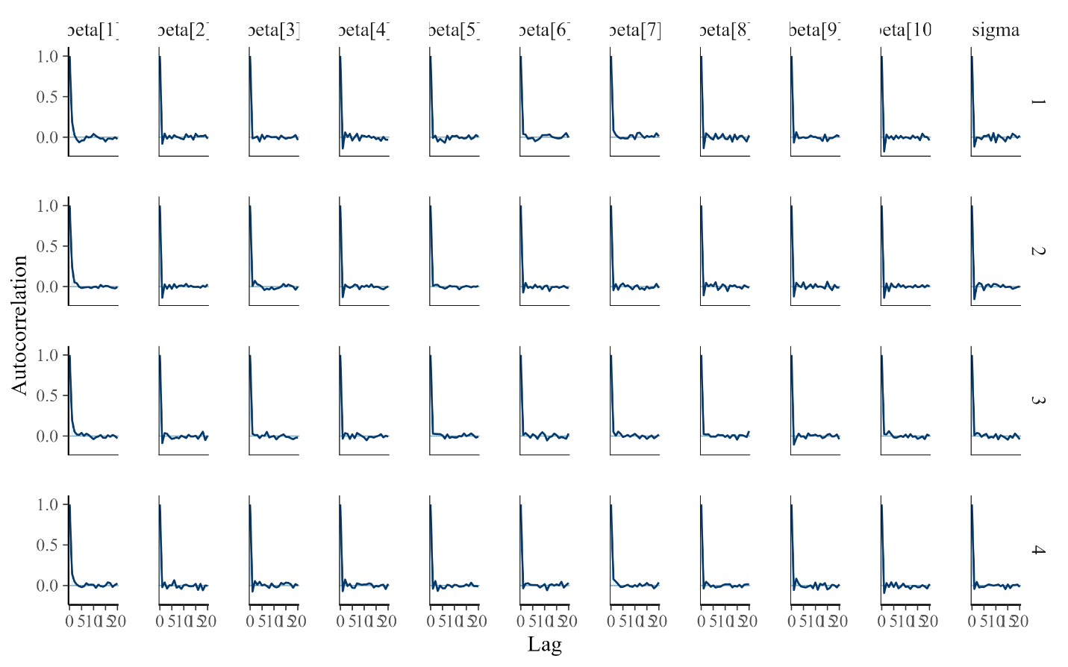

**CD4 Adjusted**

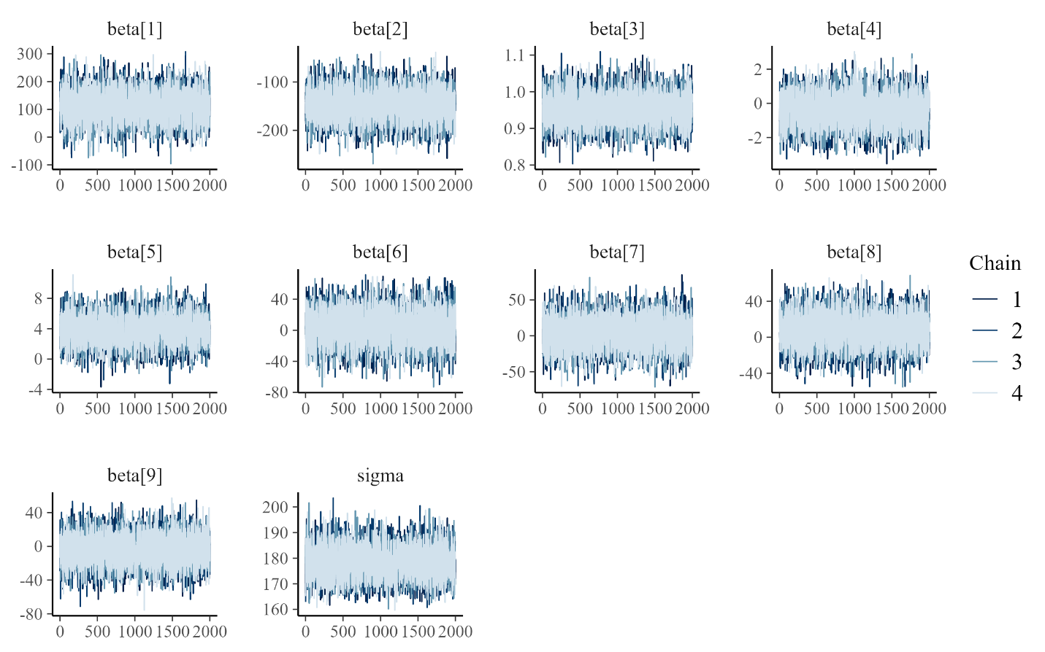

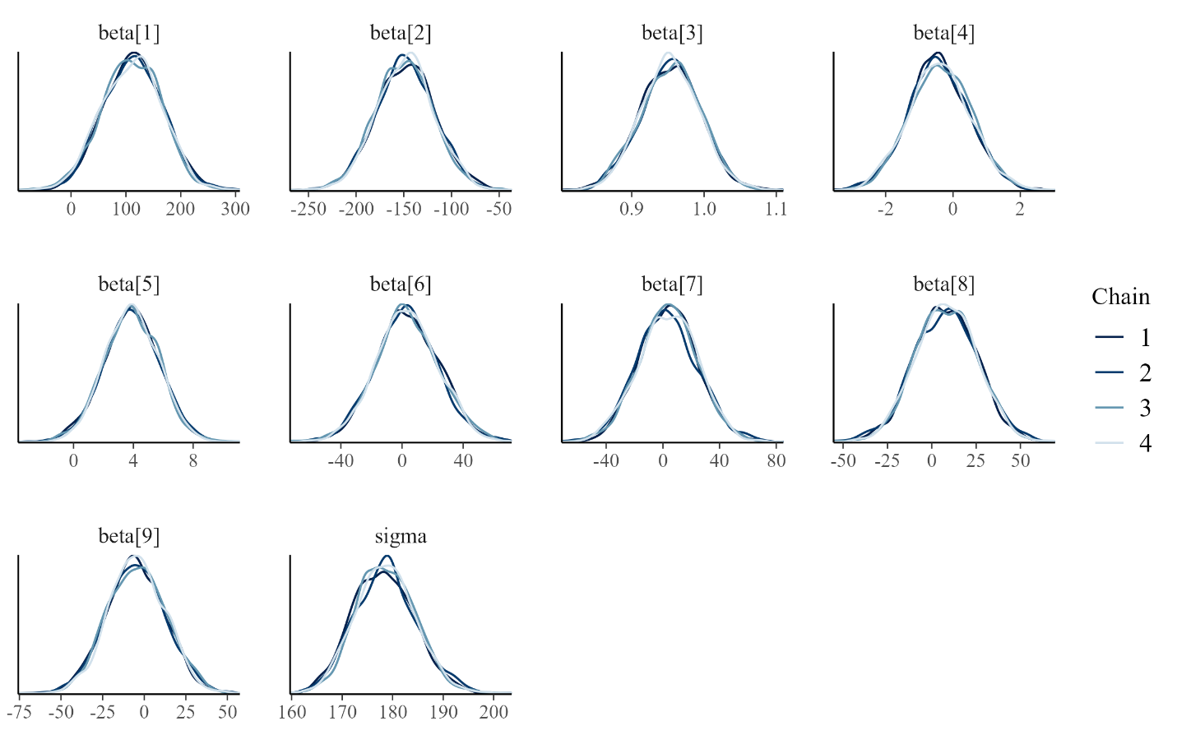

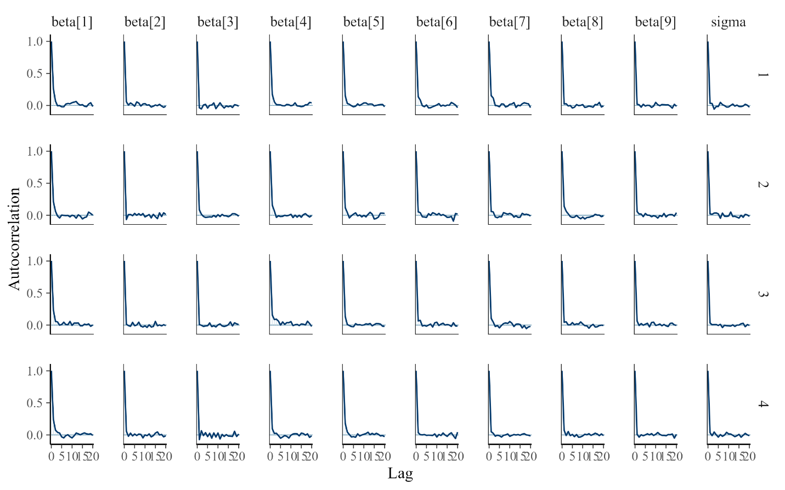

**CD4 Adjusted+ADH**

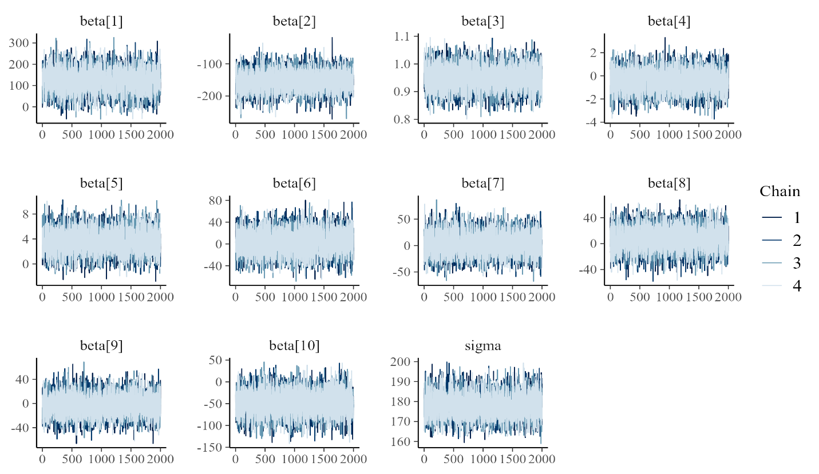

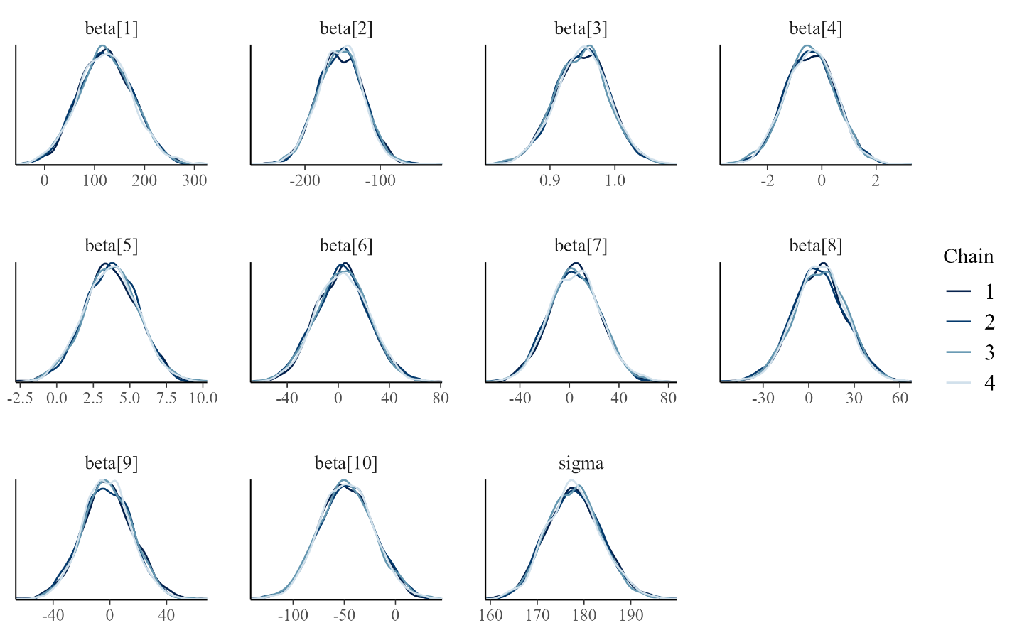

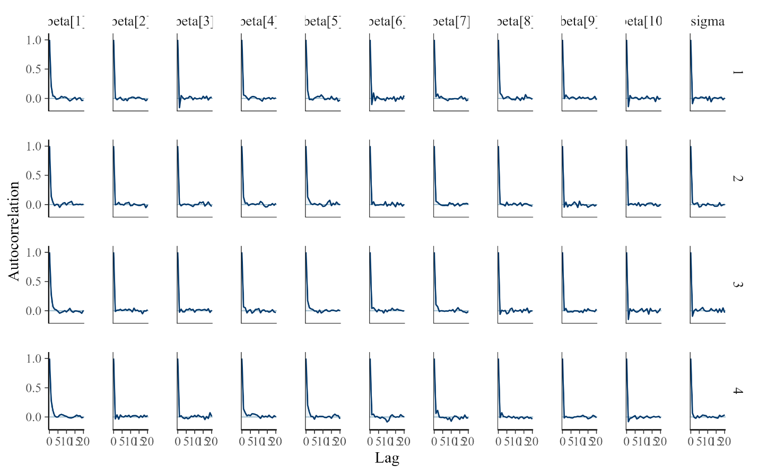

**Physical Adjusted**

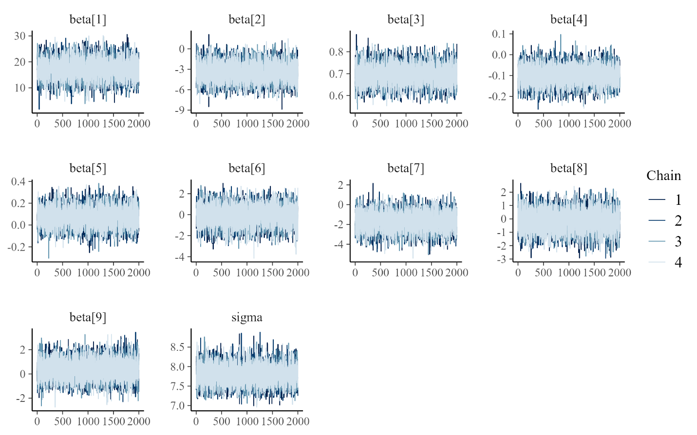

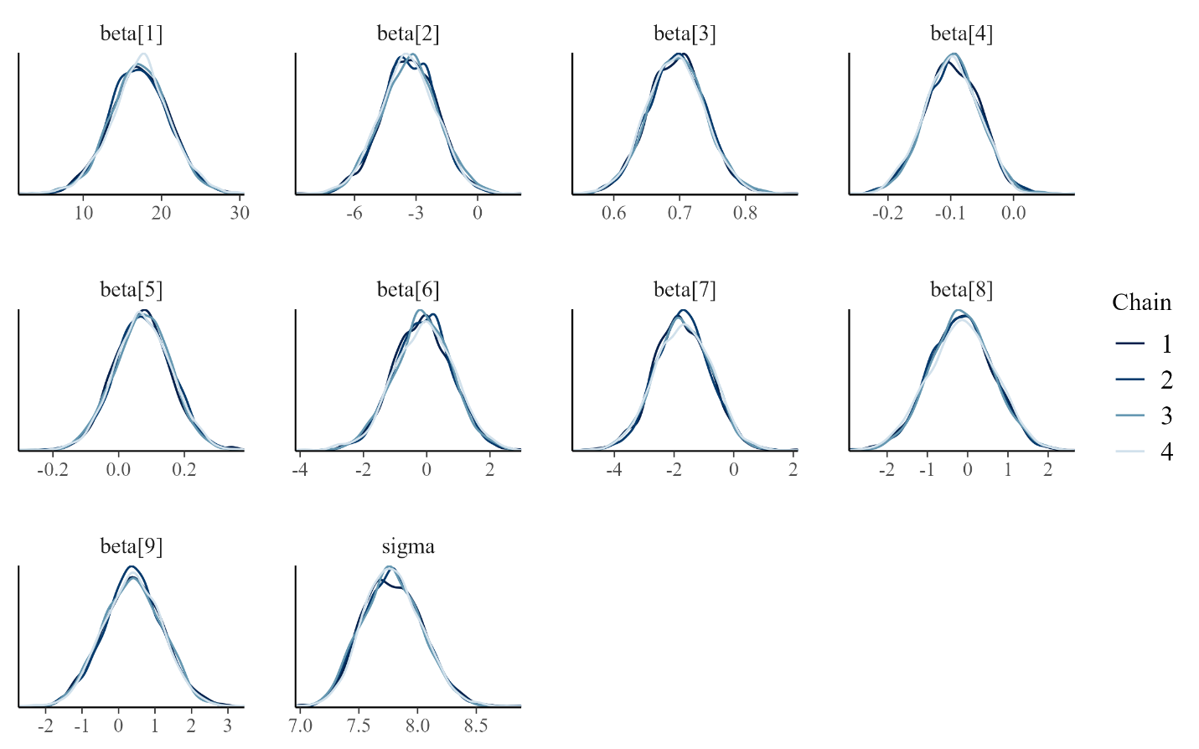

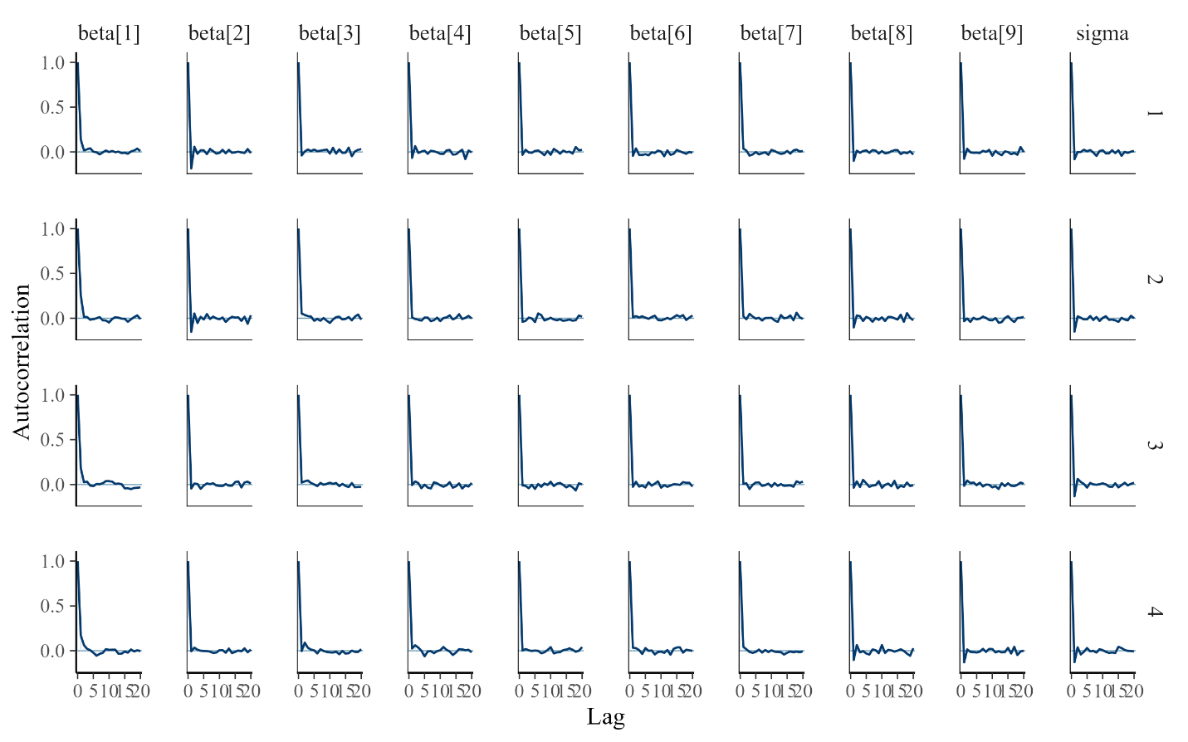

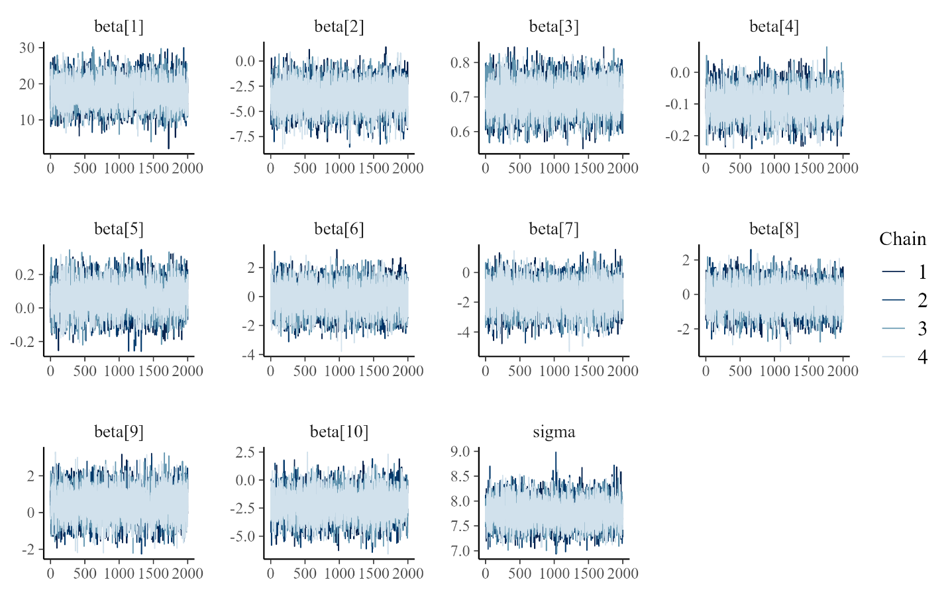**Physical Adjusted+ADH**

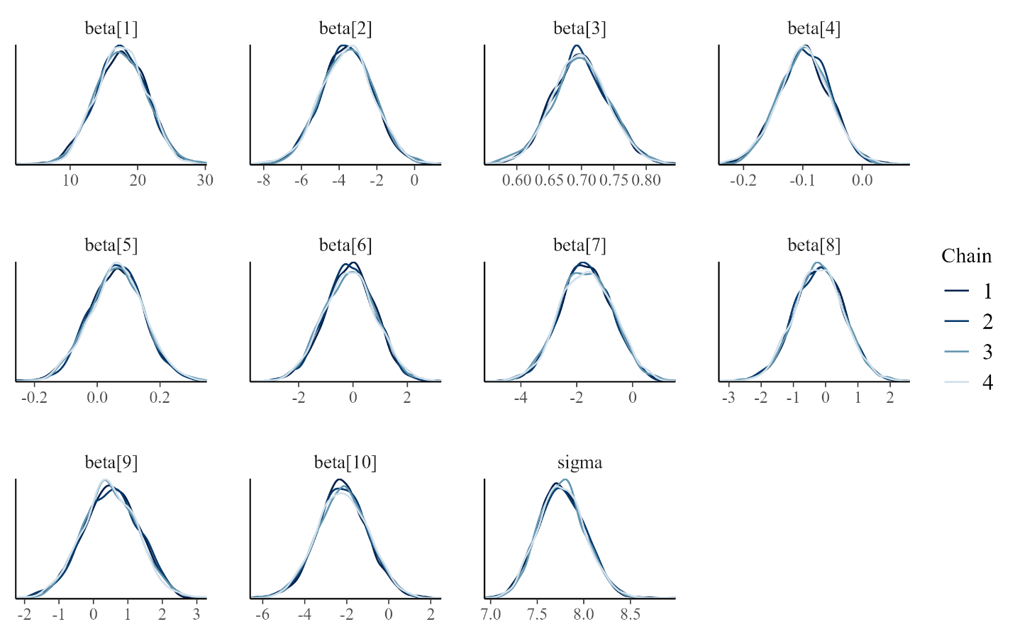

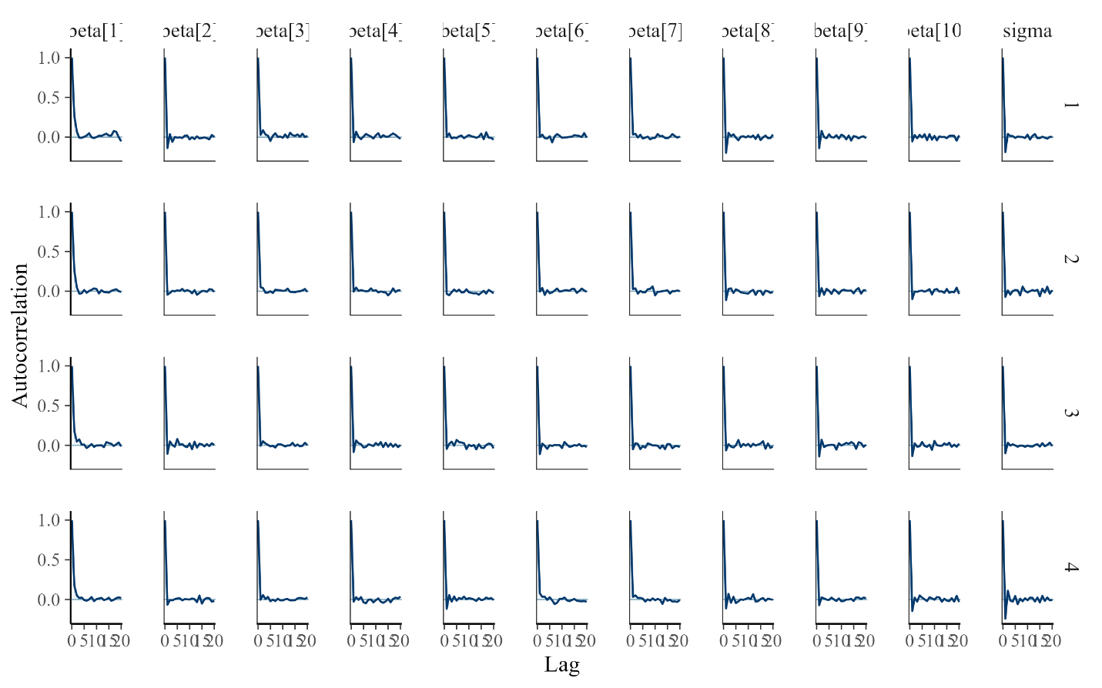

**Mental Adjusted**

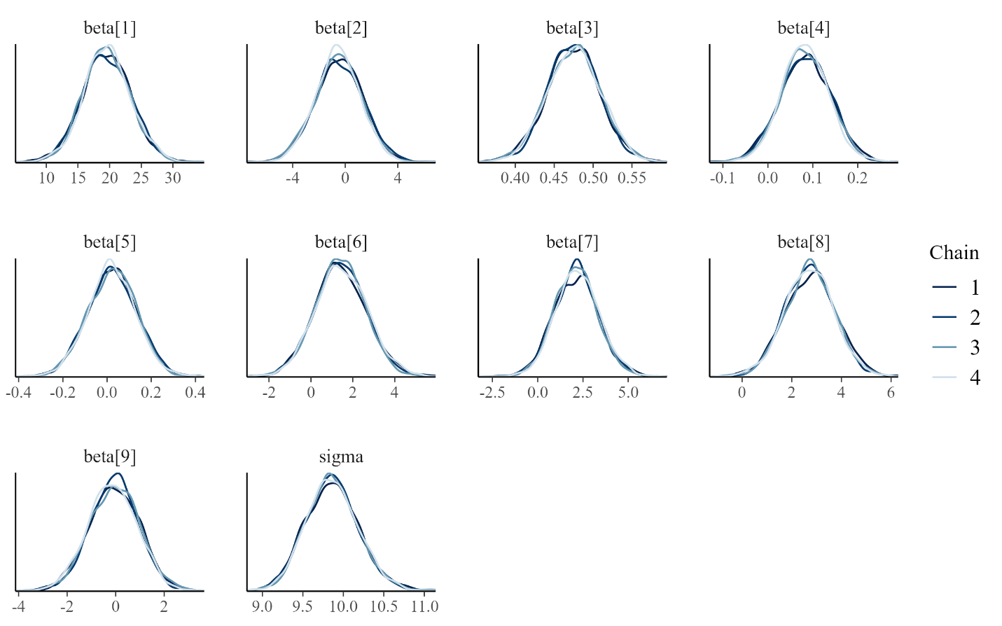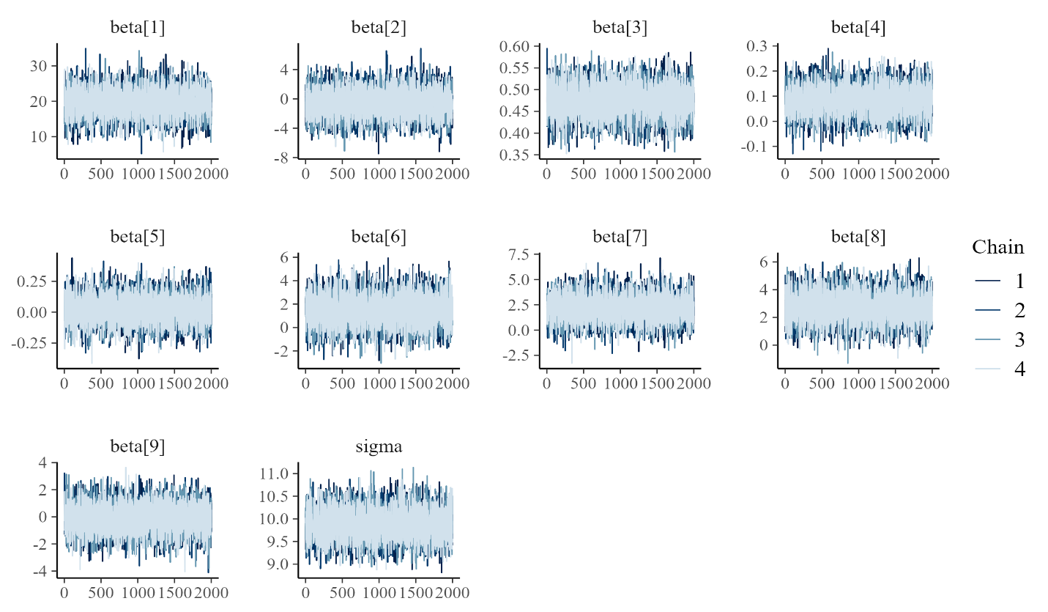

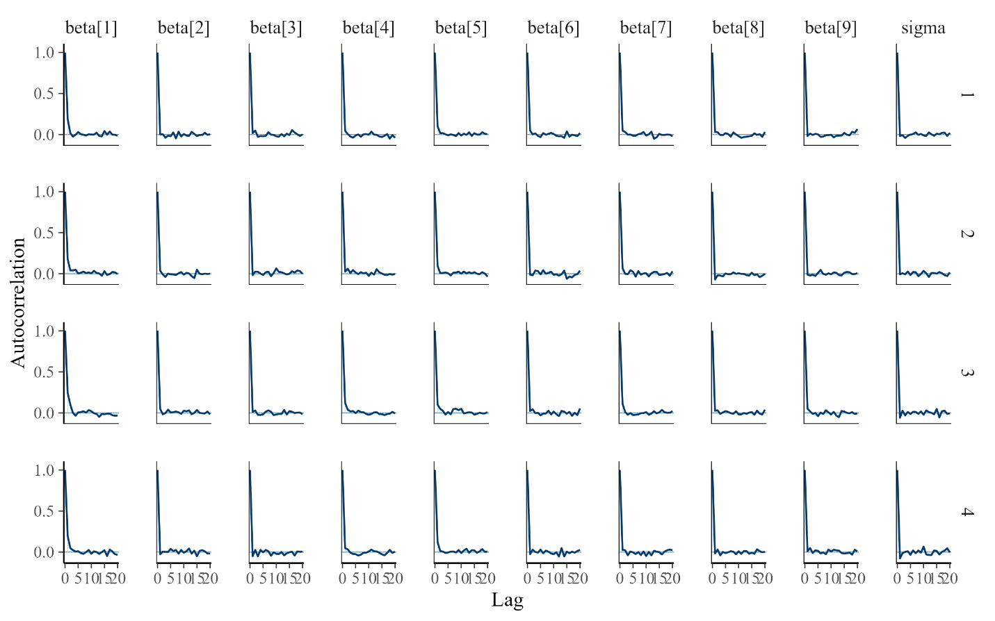

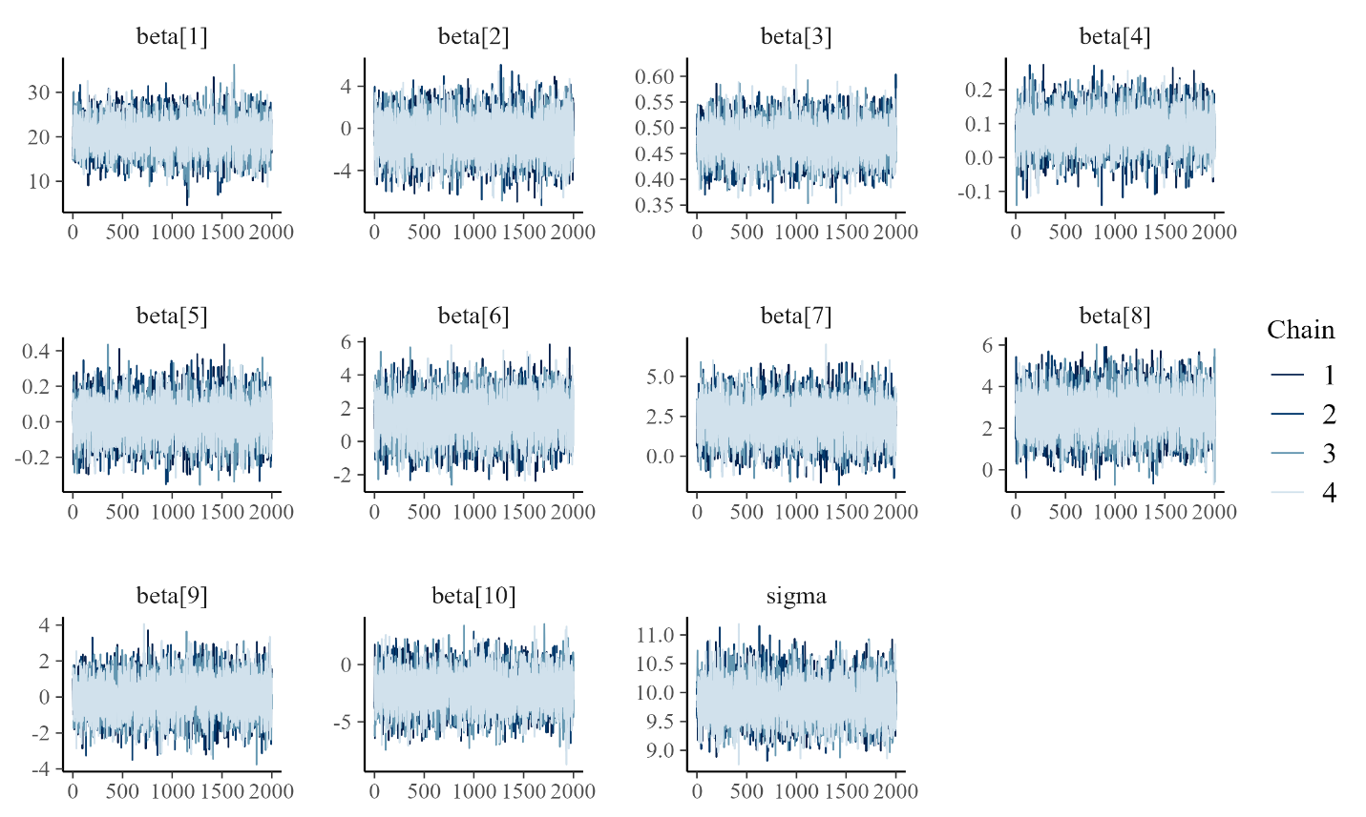**Mental Adjusted+ADH**

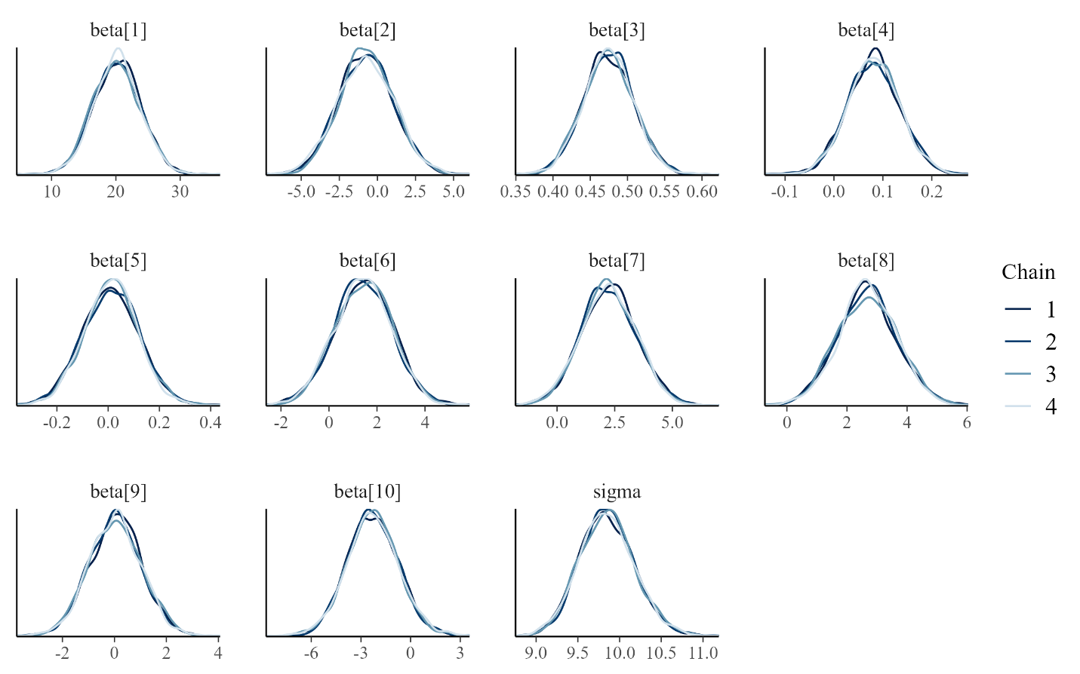

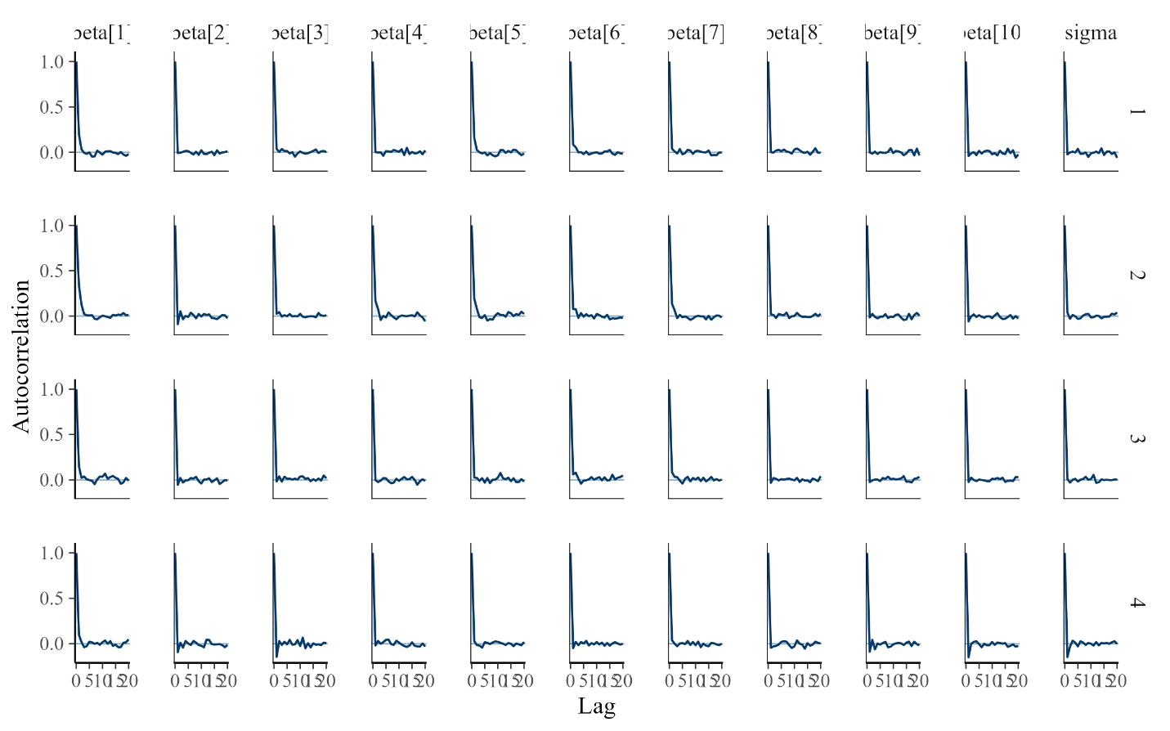

**Table A2. Convergence Diagnostics for the Hard Drug Use Effect (β₂) in Bayesian Linear Regression Models**

This table presents convergence diagnostics for the regression coefficient corresponding to baseline hard drug use (β₂) across all Bayesian models. Reported metrics include the Gelman–Rubin convergence statistic (R̂), bulk effective sample size (Bulk ESS), and tail effective sample size (Tail ESS), as obtained from CmdStanR. R̂ values near 1.000 indicate adequate mixing and convergence of Markov chains. Bulk ESS reflects sampling efficiency for estimation of posterior means, whereas Tail ESS reflects efficiency for estimation of posterior tail quantities. All models were estimated using four chains with 2,000 post-warmup iterations per chain. No divergent transitions were detected.

|  |  |  |  |  |
| --- | --- | --- | --- | --- |
| **Outcome** | **Model** | $$\hat{R}$$ | **Bulk ESS** | **Tail ESS** |
| Log10 Viral Load at Year 2 | Adjusted | 1.002 | 9936.595 | 5861.548 |
| Log10 Viral Load at Year 2 | Adjusted+ADH | 1.001 | 8913.728 | 5964.003 |
| CD4 Count at Year 2 | Adjusted | 1.000 | 7700.984 | 6227.57 |
| CD4 Count at Year 2 | Adjusted+ADH | 1.000 | 7700.984 | 6227.504 |
| Physical QOL at Year 2 | Adjusted | 1.000 | 9315.926 | 5203.923 |
| Physical QOL at Year 2 | Adjusted+ADH | 1.000 | 9572.266 | 5747.104 |
| Mental QOL at Year 2 | Adjusted | 1.001 | 7729.578 | 5372.155 |
| Mental QOL at Year 2 | Adjusted+ADH | 1.000 | 8950.451 | 5711.461 |